# **Apache Service Upgradation on windows**

**Assumptions**

This article assumes you have an existing server (real or virtual) with Apache installed on it.

Here are the steps to upgrade Apache Services:

1. Download Apache latest version from <https://www.apachelounge.com/download/#google_vignette>
2. Unzip it and copy the httpd apache file to the server.

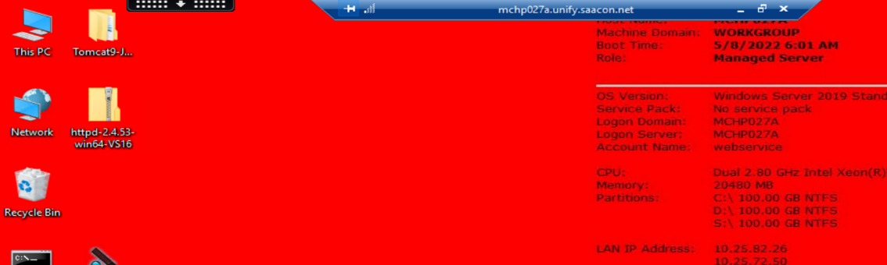

1. Check the Apache previous version.

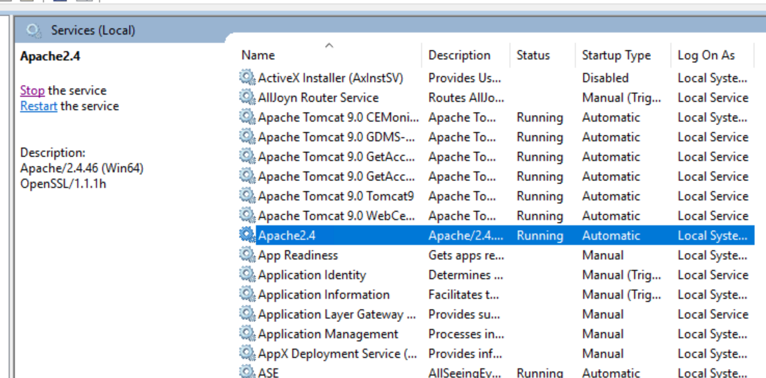

1. Back up the old Apache folder.

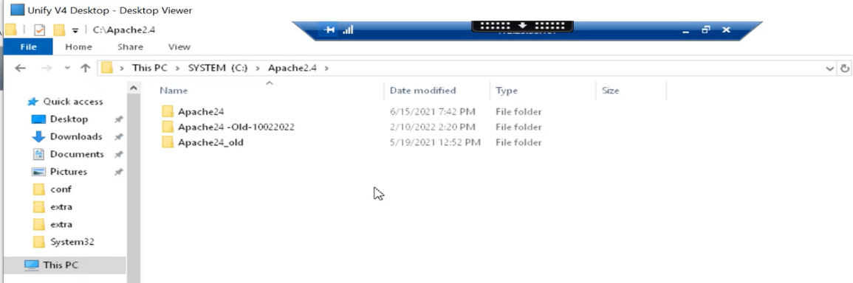

1. check the modules, htdocs, conf folders in old and new apache folders.

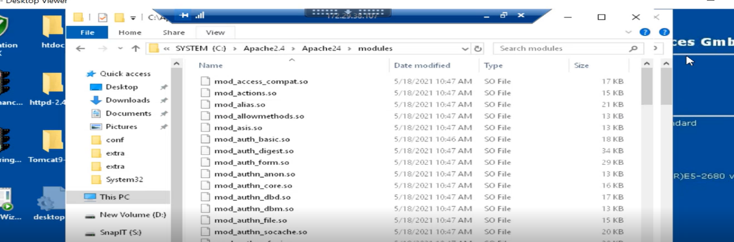

1. cut these three folders from new Apache folder and paste it in temp folder as a backup.

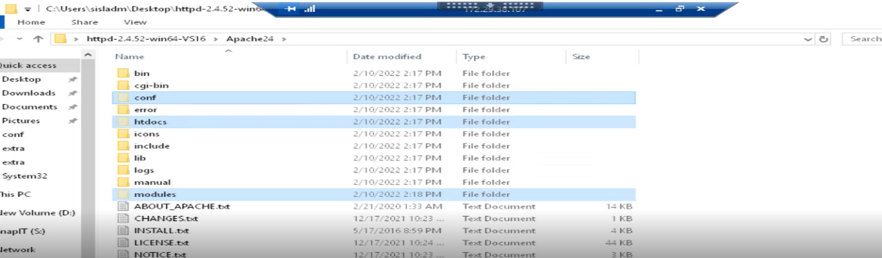

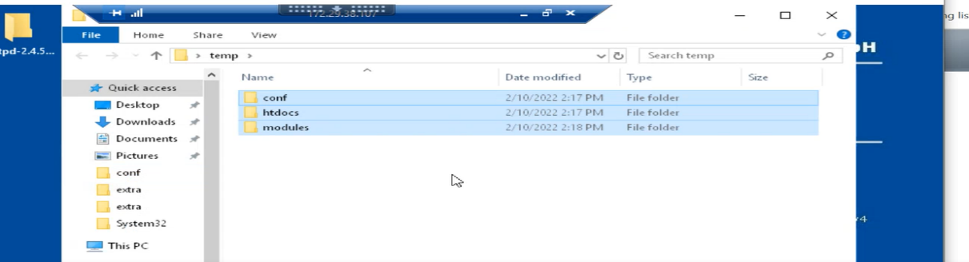

1. copy these three folders from old apache folder and paste it in new apache folder.

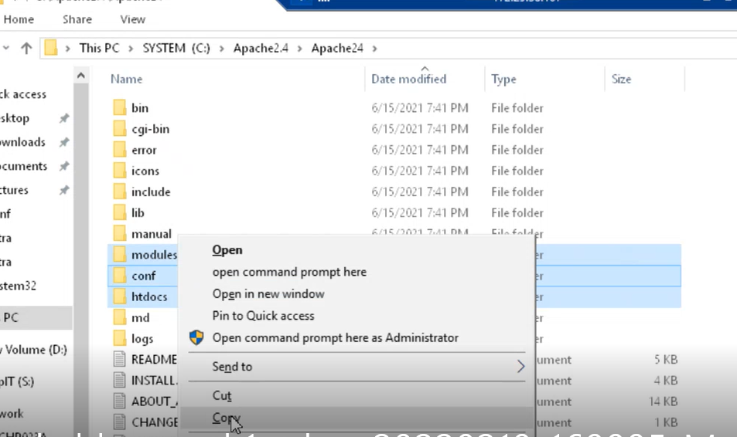

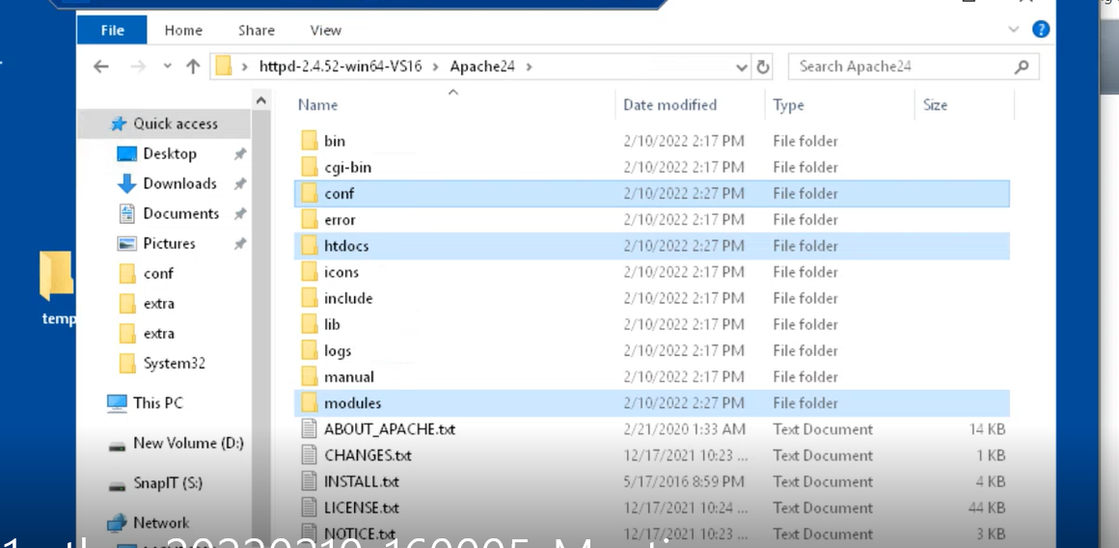

1. Stop the Apache 2.4 service.

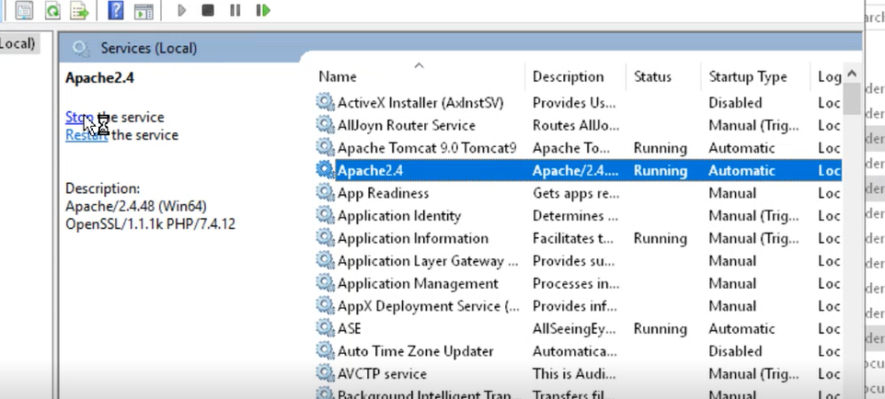

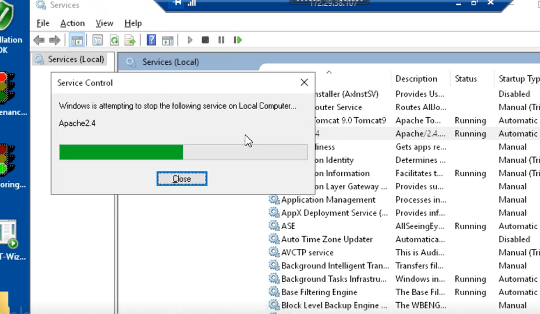

1. Replace the old Apache folder with new Apache folder

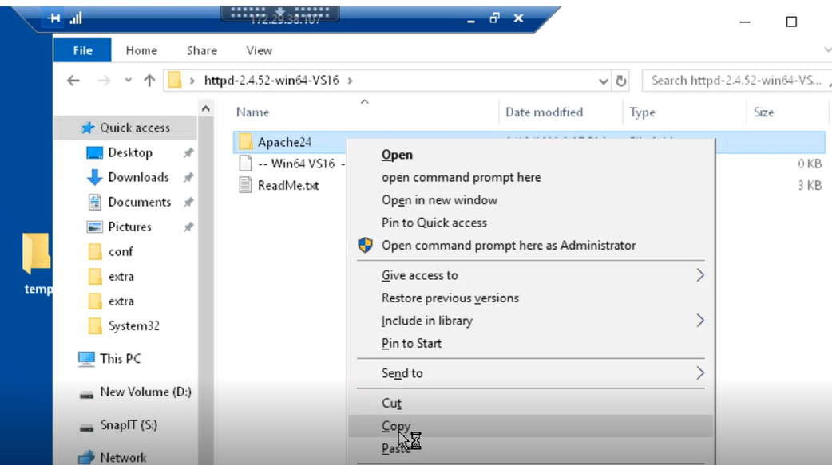

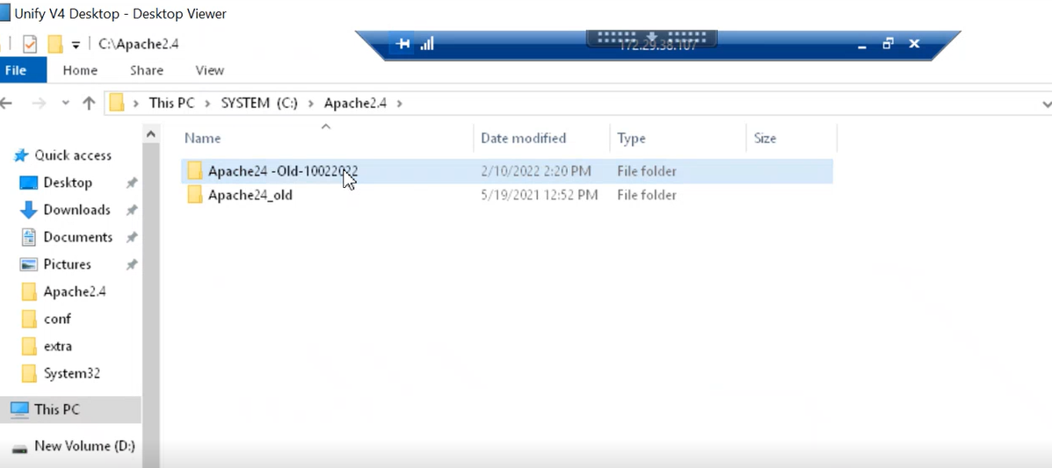

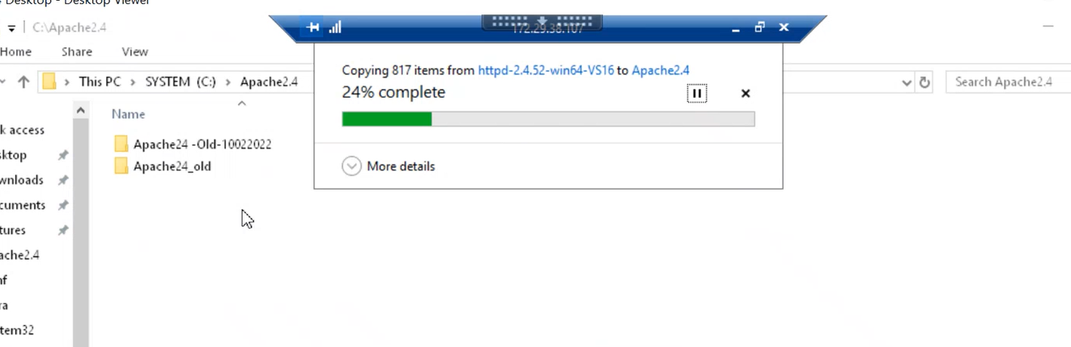

1. Click run as administrator in this path “system(C)/Apache2.4/Apache24/bin folder”.

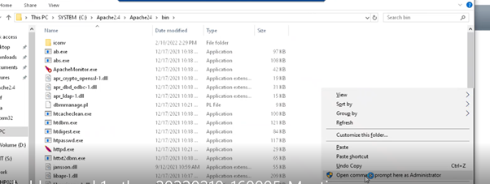

1. Run the command “http -k “

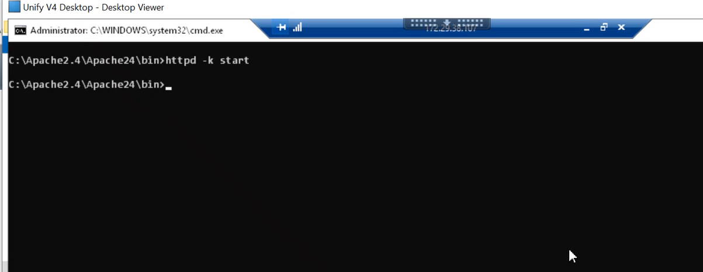

1. Refresh the services.

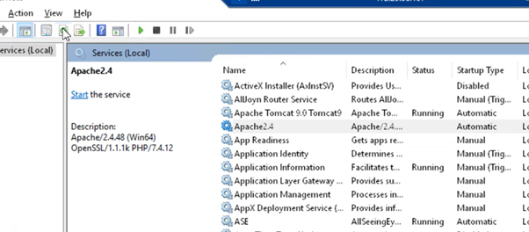

1. Now the Apache 2.4 is upgraded.

